**INDIAN GENERAL ELECTION RESULT ANALYSIS 2024**

**Total Seats:**

SELECT DISTINCT COUNT(parliament_const) as Total_Seats

FROM constitwise_results

**Result:**

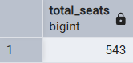

**What are the total number of seats available for election in each state?**

SELECT

s.state as state_name,

COUNT(cr.parliament_const) as total_seats

FROM constitwise_results cr

INNER JOIN statewise_results sr

ON cr.parliament_const=sr.parliament_constituency

INNER JOIN states s

ON sr.state_id=s.state_id

GROUP BY s.state

**Result:**

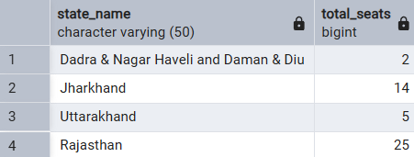

**Total seats won BY NDA Alliance:**

SELECT SUM

(

CASE WHEN party IN ('Bharatiya Janata Party - BJP',

'Telugu Desam - TDP',

'Janata Dal (United) - JD(U)',

'Shiv Sena - SHS',

'AJSU Party - AJSUP',

'Apna Dal (Soneylal) - ADAL',

'Asom Gana Parishad - AGP',

'Hindustani Awam Morcha (Secular) - HAMS',

'Janasena Party - JnP',

'Janata Dal (Secular) - JD(S)',

'Lok Janshakti Party(Ram Vilas) - LJPRV',

'Nationalist Congress Party - NCP',

'Rashtriya Lok Dal - RLD',

'Sikkim Krantikari Morcha - SKM')

THEN WON

ELSE 0

END) AS NDA_total_won

FROM partywise_results

**Result:**

**Seats Won by NDA Alliance Parties**

SELECT party,won

FROM partywise_results

WHERE party IN ('Bharatiya Janata Party - BJP',

'Telugu Desam - TDP',

'Janata Dal (United) - JD(U)',

'Shiv Sena - SHS',

'AJSU Party - AJSUP',

'Apna Dal (Soneylal) - ADAL',

'Asom Gana Parishad - AGP',

'Hindustani Awam Morcha (Secular) - HAMS',

'Janasena Party - JnP',

'Janata Dal (Secular) - JD(S)',

'Lok Janshakti Party(Ram Vilas) - LJPRV',

'Nationalist Congress Party - NCP',

'Rashtriya Lok Dal - RLD',

'Sikkim Krantikari Morcha - SKM')

ORDER BY won

**Result:**

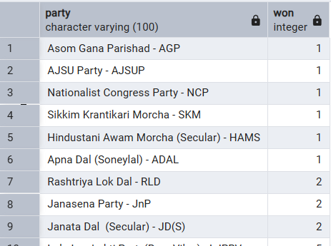

**Total Seats Won by I.N.D.I.A. Allianz**

SELECT SUM(

CASE

WHEN party IN ('Indian National Congress - INC',

'Aam Aadmi Party - AAAP',

'All India Trinamool Congress - AITC',

'Bharat Adivasi Party - BHRTADVSIP',

'Communist Party of India (Marxist) - CPI(M)',

'Communist Party of India (Marxist-Leninist) (Liberation) - CPI(ML)(L)',

'Communist Party of India - CPI',

'Dravida Munnetra Kazhagam - DMK',

'Indian Union Muslim League - IUML',

'Nat`Jammu & Kashmir National Conference - JKN',

'Jharkhand Mukti Morcha - JMM',

'Jammu & Kashmir National Conference - JKN',

'Kerala Congress - KEC',

'Marumalarchi Dravida Munnetra Kazhagam - MDMK',

'Nationalist Congress Party Sharadchandra Pawar - NCPSP',

'Rashtriya Janata Dal - RJD',

'Rashtriya Loktantrik Party - RLTP',

'Revolutionary Socialist Party - RSP',

'Samajwadi Party - SP',

'Shiv Sena (Uddhav Balasaheb Thackrey) - SHSUBT',

'Viduthalai Chiruthaigal Katchi - VCK')

THEN won

ELSE 0

END) AS INDIA_ally_won

FROM partywise_results

**Result:**

**Seats Won by I.N.D.I.A Alliance Parties**

SELECT party,won

FROM partywise_results

WHERE party

IN ('Indian National Congress - INC',

'Aam Aadmi Party - AAAP',

'All India Trinamool Congress - AITC',

'Bharat Adivasi Party - BHRTADVSIP',

'Communist Party of India (Marxist) - CPI(M)',

'Communist Party of India (Marxist-Leninist) (Liberation) - CPI(ML)(L)',

'Communist Party of India - CPI',

'Dravida Munnetra Kazhagam - DMK',

'Indian Union Muslim League - IUML',

'Nat`Jammu & Kashmir National Conference - JKN',

'Jharkhand Mukti Morcha - JMM',

'Jammu & Kashmir National Conference - JKN',

'Kerala Congress - KEC',

'Marumalarchi Dravida Munnetra Kazhagam - MDMK',

'Nationalist Congress Party Sharadchandra Pawar - NCPSP',

'Rashtriya Janata Dal - RJD',

'Rashtriya Loktantrik Party - RLTP',

'Revolutionary Socialist Party - RSP',

'Samajwadi Party - SP',

'Shiv Sena (Uddhav Balasaheb Thackrey) - SHSUBT',

'Viduthalai Chiruthaigal Katchi - VCK')

**Result:**

**Adding a new column field in the table partywise_results to get the party allianz as NDA or I.N.D.I.A**

ALTER TABLE partywise_results

ADD party_alliance VARCHAR(50);

**NDA Allianz**

UPDATE partywise_results

SET party_alliance='NDA'

WHERE party IN('Bharatiya Janata Party - BJP',

'Telugu Desam - TDP',

'Janata Dal (United) - JD(U)',

'Shiv Sena - SHS',

'AJSU Party - AJSUP',

'Apna Dal (Soneylal) - ADAL',

'Asom Gana Parishad - AGP',

'Hindustani Awam Morcha (Secular) - HAMS',

'Janasena Party - JnP',

'Janata Dal (Secular) - JD(S)',

'Lok Janshakti Party(Ram Vilas) - LJPRV',

'Nationalist Congress Party - NCP',

'Rashtriya Lok Dal - RLD',

'Sikkim Krantikari Morcha - SKM')

**

**I.N.D.I.A Allianz**

UPDATE partywise_results

SET party_alliance = 'I.N.D.I.A'

WHERE party IN (

'Indian National Congress - INC',

'Aam Aadmi Party - AAAP',

'All India Trinamool Congress - AITC',

'Bharat Adivasi Party - BHRTADVSIP',

'Communist Party of India (Marxist) - CPI(M)',

'Communist Party of India (Marxist-Leninist) (Liberation) - CPI(ML)(L)',

'Communist Party of India - CPI',

'Dravida Munnetra Kazhagam - DMK',

'Indian Union Muslim League - IUML',

'Jammu & Kashmir National Conference - JKN',

'Jharkhand Mukti Morcha - JMM',

'Kerala Congress - KEC',

'Marumalarchi Dravida Munnetra Kazhagam - MDMK',

'Nationalist Congress Party Sharadchandra Pawar - NCPSP',

'Rashtriya Janata Dal - RJD',

'Rashtriya Loktantrik Party - RLTP',

'Revolutionary Socialist Party - RSP',

'Samajwadi Party - SP',

'Shiv Sena (Uddhav Balasaheb Thackrey) - SHSUBT',

'Viduthalai Chiruthaigal Katchi - VCK');

**Result:**

**OTHER**

UPDATE partywise_results

SET party_alliance = 'OTHER'

WHERE party_alliance IS NULL;

**Winning candidate's name, their party name, total votes, and the margin of victory for a specific state and constituency?**

SELECT cr.Winning_Candidate, p.Party, p.party_alliance, cr.Total_Votes, cr.Margin, cr.Constituency_Name, s.State

FROM constitwise_results cr

JOIN partywise_results p ON cr.Party_ID = p.Party_ID

JOIN statewise_results sr ON cr.parliament_const = sr.parliament_constituency

JOIN states s ON sr.State_ID = s.State_ID

WHERE s.State = 'Uttar Pradesh' AND cr.Constituency_Name = 'AMETHI';

**Result:**



**Winning candidate's name, their party name, total votes, and the margin of victory for a specific state and constituency?**

SELECT cr.Winning_Candidate, p.Party, p.party_alliance, cr.Total_Votes, cr.Margin, cr.Constituency_Name, s.State

FROM constitwise_results cr

JOIN partywise_results p ON cr.Party_ID = p.Party_ID

JOIN statewise_results sr ON cr.parliament_const = sr.parliament_constituency

JOIN states s ON sr.State_ID = s.State_ID

WHERE s.State = 'Uttar Pradesh' AND cr.Constituency_Name = 'AMETHI';

**What is the distribution of EVM votes versus postal votes for candidates in a specific constituency?**

SELECT cr.constituency_name,cd.candidate,cd.evm_votes,cd.postal_votes

FROM constitwise_results cr

INNER JOIN constitwise_details cd

ON cr.constituency_id=cd.constit_id

WHERE cr.constituency_name='AGRA'

**Result:**

**Which party won the most seats in s State, and how many seats did each party win?**

SELECT pr.party,COUNT(DISTINCT cr.constituency_id) AS seats_won FROM partywise_results pr

INNER JOIN constitwise_results cr

ON pr.party_id=cr.party_id

INNER JOIN statewise_results sr

ON cr.parliament_const=sr.parliament_constituency

INNER JOIN states s

ON sr.state_id=s.state_id

WHERE s.state='Uttar Pradesh'

**Reuslt:**

**What is the total number of seats won by each party alliance (NDA, I.N.D.I.A, and OTHER) in each state for the India Elections 2024**

SELECT DISTINCT pr.party_alliance AS Ally,COUNT(*) FROM partywise_results pr

INNER JOIN constitwise_results cr

ON pr.party_id=cr.party_id

INNER JOIN statewise_results sr

ON cr.parliament_const=sr.parliament_constituency

INNER JOIN states s

ON sr.state_id=s.state_id

WHERE s.state='Uttar Pradesh'

GROUP BY pr.party_alliance

**Result:**

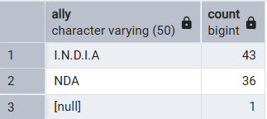

**Which candidate received the highest number of EVM votes in each constituency (Top 10)?**

SELECT cr.constituency_name,cd.candidate,cd.evm_votes as votes

FROM constitwise_details cd

JOIN constitwise_results cr

ON cd.constit_id=cr.constituency_id

WHERE cd.evm_votes=(SELECT MAX(cd2.evm_votes) FROM constitwise_details cd2

WHERE cd2.constit_id=cd.constit_id)

GROUP BY cr.constituency_name,cd.candidate,votes

ORDER BY votes DESC

LIMIT 10;

**Result:**

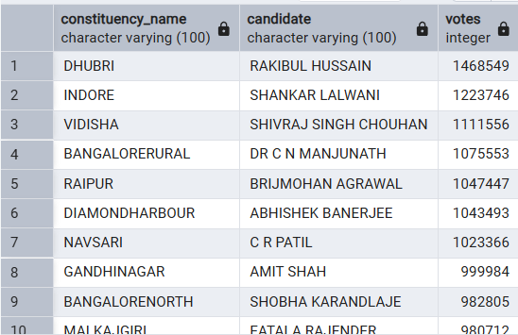

**Which candidate won and which candidate was the runner-up in each constituency of State for the 2024 elections?**

WITH rankedcandidate AS(

SELECT

cd.constit_id,

cd.candidate,

cd.evm_votes,

cd.postal_votes,

cd.evm_votes + cd.postal_votes as Total_votes,

ROW_NUMBER() OVER(PARTITION BY cd.constit_id ORDER BY (cd.evm_votes +cd.postal_votes) DESC

) AS VoteRank

FROM constitwise_details cd

JOIN constitwise_results cr

ON cd.constit_id=cr.constituency_id

JOIN statewise_results sr

ON cr.parliament_const=sr.parliament_constituency

JOIN states s ON sr.state_id=s.state_id

WHERE s.state='Maharashtra')

SELECT

cr.constituency_name,

MAX(CASE WHEN rc.VoteRank = 1 THEN rc.Candidate END) AS Winning_Candidate,

MAX(CASE WHEN rc.VoteRank = 2 THEN rc.Candidate END) AS Runnerup_Candidate

FROM

RankedCandidate rc

JOIN

constitwise_results cr ON rc.constit_id = cr.constituency_id

GROUP BY

cr.Constituency_Name

ORDER BY

cr.Constituency_Name;

**Result:**

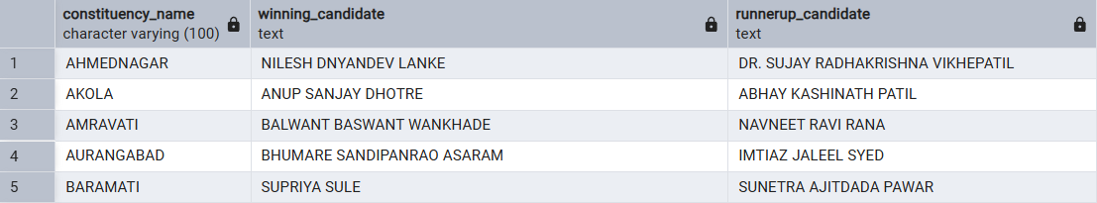

**For the state of Maharashtra, what are the total number of seats, total number of candidates, total number of parties, total votes (including EVM and postal), and the breakdown of EVM and postal votes?**

SELECT COUNT(DISTINCT cr.constituency_name) as total_seats,count(DISTINCT cd.candidate) as total_candidate,count(DISTINCT pr.party) as total_party,SUM(cd.total_votes),SUM(cd.evm_votes),SUM(cd.postal_votes)

FROM constitwise_details cd

JOIN constitwise_results cr

ON cd.constit_id=cr.constituency_id

JOIN partywise_results pr

ON cr.party_id=pr.party_id

JOIN statewise_results sr

ON cr.parliament_const=sr.parliament_constituency

JOIN states s

ON sr.state_id=s.state_id

WHERE s.state='Bihar'

**Result:**

